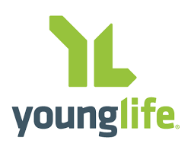
I, _____________________________________________________ give my consent & permission for
(Print Parent or Guardian Name)

_________________________________________________________ to participate in the following:
(Print Student’s Name)

(Please check as many as apply)

Year of Participation: ______ 2021/2022 ______ 2022/2023

1. ______ I entrust the leaders and volunteers to supervise my child while participating in club on the grounds of the Ketterlinus Gym. Each leader has been screened through the Young Life national service center.

2. ______ I entrust the leaders and volunteers to transport my child to and from activities if needed. Each leader has completed a driver screening test through the Young Life national service center.

SCHOLARSHIP OPPORTUNITIES
Young Life strives to ensure that each participant have equal-opportunities to attend any event, including camps. In order for this to happen, our organization has been given scholarship money to off-set these costs. To allow us to use this money for your child, please check any of the following that apply to your family:

1. _____ Reduced/ free school lunch. 2. _____ Head Start program 3. _____ Food Stamp Program
*this information will remain completely confidential and only be needed as proof in the rare event of an IRS audit*

Under penalties of perjury, I swear and affirm that all information herein is true and correct to the best of my knowledge.

____________________________ ______________________________ ______________
(Parent/ Guardian Signature) (Parent/ Guardian Printed Name) (Date)

